import com.mongodb.client.*;
import com.mongodb.client.model.Filters;
import com.mongodb.client.model.Updates;
import org.bson.Document;
public class MongoCRUDExample {
public static void main(String[] args) {
// Connect to MongoDB
MongoClient mongoClient = MongoClients.create("mongodb://localhost:27017");
// Access database
MongoDatabase database = mongoClient.getDatabase("CollegeDB");
// Access collection
MongoCollection<Document> collection =
database.getCollection("Students");
// ==========================
// CREATE (Insert)
// ==========================
Document student = new Document("id", 101)
.append("name", "John")
.append("department", "CSE")
.append("cgpa", 8.7);
collection.insertOne(student);
System.out.println("Document Inserted Successfully");
// ==========================
// READ (Find)
// ==========================
System.out.println("\nStudent Records:");
FindIterable<Document> students = collection.find();
for (Document doc : students) {
System.out.println(doc.toJson());
}
// ==========================
// UPDATE
// ==========================
collection.updateOne(
Filters.eq("id", 101),
Updates.set("cgpa", 9.2)
);
System.out.println("\nDocument Updated Successfully");
// ==========================
// READ Updated Record
// ==========================
Document updatedStudent =
collection.find(Filters.eq("id", 101)).first();
System.out.println("\nUpdated Record:");
System.out.println(updatedStudent.toJson());
// ==========================
// DELETE
// ==========================
collection.deleteOne(Filters.eq("id", 101));
System.out.println("\nDocument Deleted Successfully");
// Close connection
mongoClient.close();
}
}
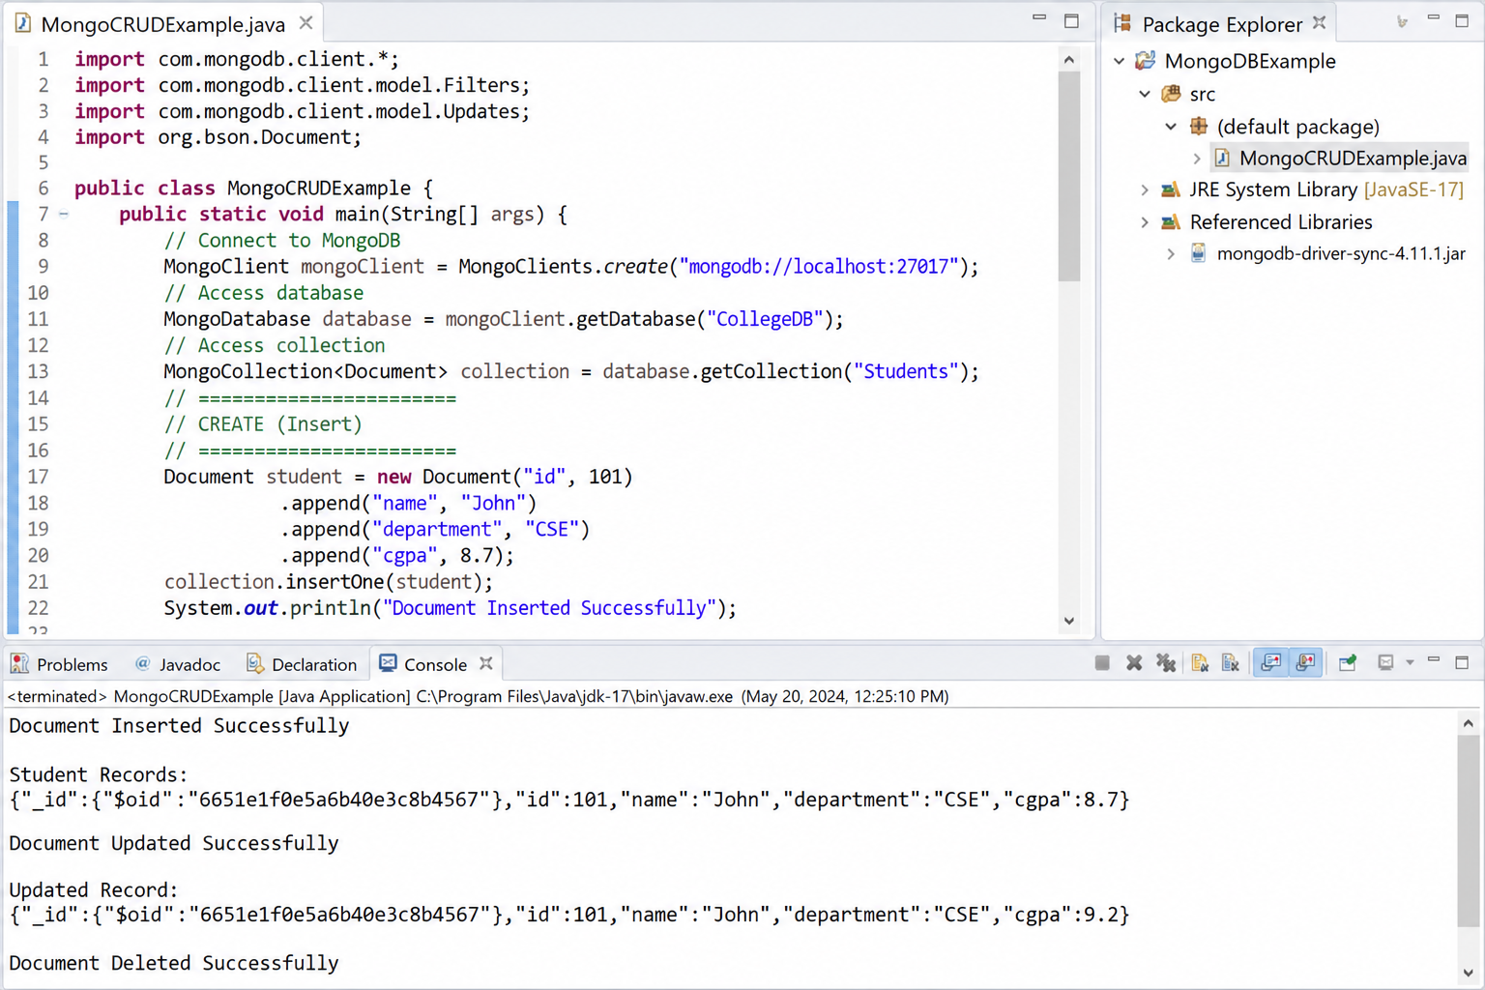
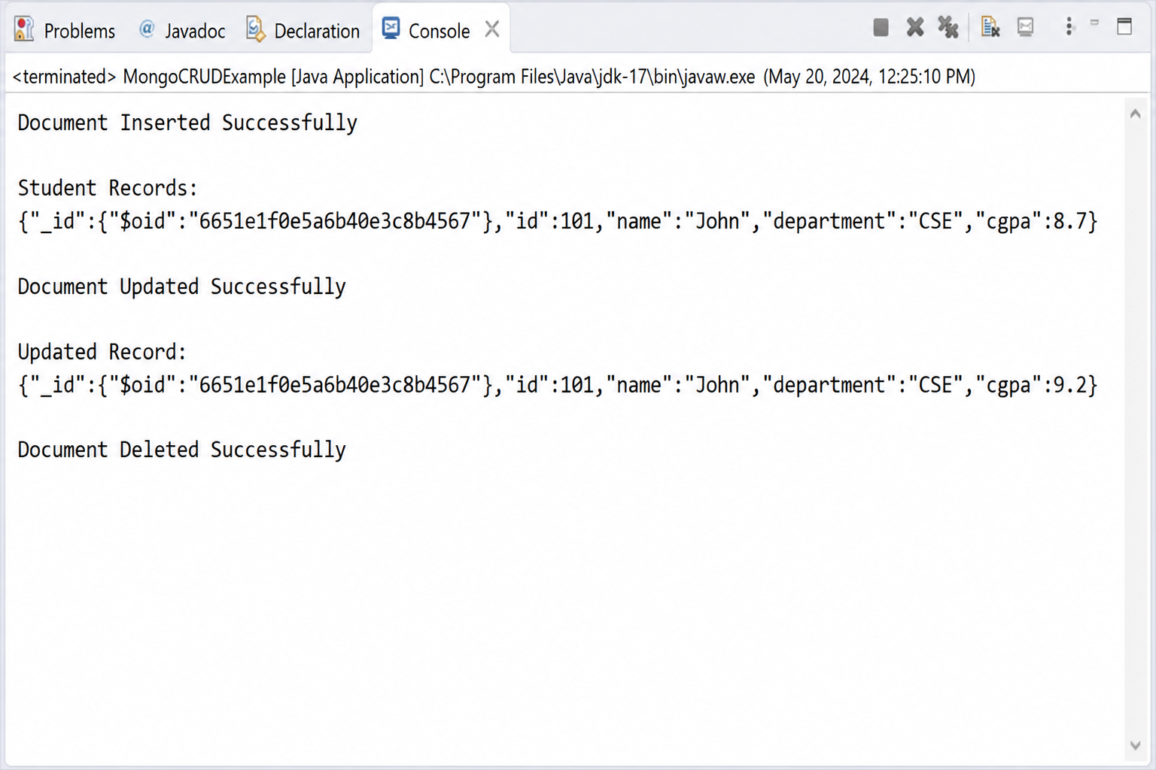
import com.mongodb.client.*;
import com.mongodb.client.model.Filters;
import com.mongodb.client.model.Updates;
import org.bson.Document;

import java.util.Arrays;

public class MongoCRUDManyExample {

public static void main(String[] args) {

// Connect to MongoDB
MongoClient mongoClient =
MongoClients.create("mongodb://localhost:27017");

// Database
MongoDatabase database =
mongoClient.getDatabase("CollegeDB");

// Collection
MongoCollection<Document> collection =
database.getCollection("Students");

// Clear old data
collection.deleteMany(new Document());

// ==========================
// INSERT MANY
// ==========================
collection.insertMany(Arrays.asList(
new Document("id", 1)
.append("name", "Alice")
.append("department", "CSE")
.append("cgpa", 8.5),

new Document("id", 2)
.append("name", "Bob")
.append("department", "IT")
.append("cgpa", 7.8),

new Document("id", 3)
.append("name", "Charlie")
.append("department", "ECE")
.append("cgpa", 9.1)
));

System.out.println("===== Insert Many Documents =====");
System.out.println("3 Documents Inserted Successfully");

// ==========================
// READ ALL
// ==========================
System.out.println("\nAll Student Records:");

FindIterable<Document> students =
collection.find();

for (Document doc : students) {
System.out.println(doc.toJson());
}

// ==========================
// UPDATE MANY
// ==========================
collection.updateMany(
Filters.gte("cgpa", 7.0),
Updates.inc("cgpa", 0.5)
);

System.out.println("\n===== Update Many Documents =====");
System.out.println("Documents Updated Successfully");

// READ UPDATED RECORDS
System.out.println("\nUpdated Student Records:");

for (Document doc : collection.find()) {
System.out.println(doc.toJson());
}

// ==========================
// DELETE MANY
// ==========================
collection.deleteMany(
Filters.gte("cgpa", 8.0)
);

System.out.println("\n===== Delete Many Documents =====");
System.out.println("Documents Deleted Successfully");

// READ AFTER DELETE
System.out.println("\nAll Student Records After Deletion:");

FindIterable<Document> remaining =
collection.find();

boolean found = false;

for (Document doc : remaining) {
found = true;
System.out.println(doc.toJson());
}

if (!found) {
System.out.println("(No documents found)");
}

mongoClient.close();
}
}

